DESCRIPTION OF SLIDES USED IN THE VIDEO SERIES -
Resource package on collecting and analyzing data on persons with disabilities

Slide: Global Disability Prevalence Rates

High-income countries
Country | Year | %
Canada | 1991 | 14.7
Germany | 1992 | 8.4
Italy | 1994 | 5.0
Netherlands | 1986 | 11.6
Norway | 1995 | 17.8
Sweden | 1988 | 12.1
Spain | 1986 | 15.0
UK | 1991 | 12.2
USA | 1994 | 15.0

Low- or middle-income countries
Country | Year | %
Kenya | 1989 | 0.7
Namibia | 1991 | 3.1
Nigeria | 1991 | 0.5
Senegal | 1988 | 1.1
South Africa | 1980 | 0.5
Malawi | 1983 | 2.9
Zambia | 1990 | 0.9
Zimbabwe | 1997 | 1.9
The table illustrates how disability prevalence rates have varied widely in the past. It shows disability prevalence rates for 9 high-income countries and 8 low- and middle-income countries. What is striking is that very often in high-income countries the disability prevalence rates are much higher (most often over 10%) than in low- and middle-income countries (most below 3% and many below 1%).

Slide: The ICF Model – 2001
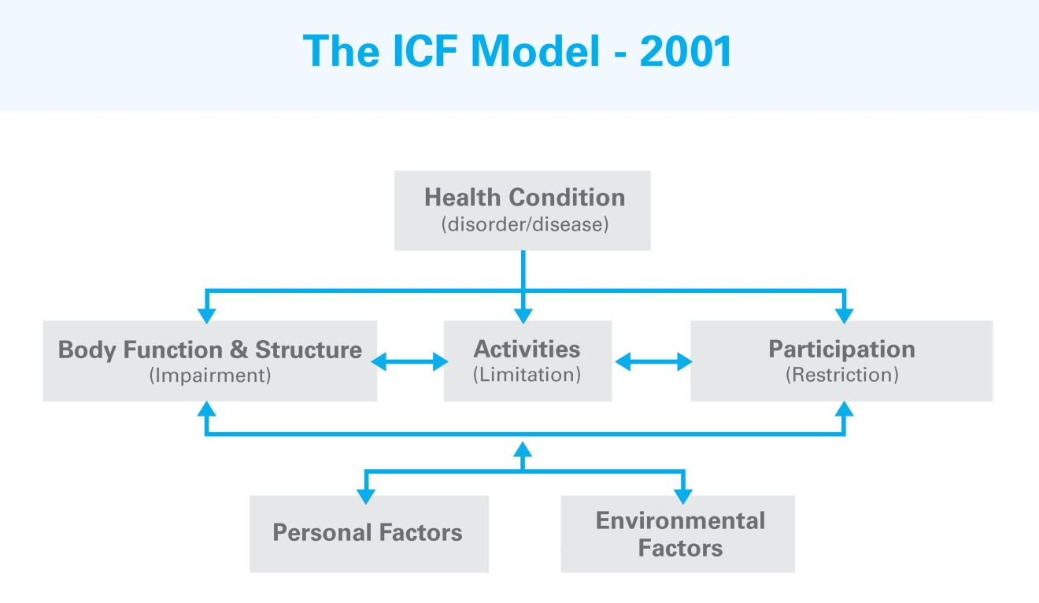
The slide shows the International Classification of Functioning, Disability and Health (ICF). The ICF provides a system of classifying all aspects of disability, including health conditions (diseases or disorders), body functions and structures (impairments), activity limitations, and participation restrictions, we all as personal factors and environmental factors (barriers and facilitators). All the elements are interconnected.

Slide: Disability Prevalence U.S.A
Person with disability has:
 | N | %
at least 1 Domain is 'some difficulty' | 7511 | 41.9
at least 2 Domains are 'some difficulty' | 3672 | 19.6
at least 1 Domain is 'a lot of difficulty' | 1872 | 9.5
at least 1 Domain is 'unable to do it' | 465 | 2.2
The table presents data from the 2013 US National health interview Survey (NHIS) and reflects the adult population 18 years of age and older.
Using the WG Short Set of questions, it is possible to define a person as having disability if they answered to at least one of the six questions: unable to do it (cannot do at all). This is the bottom line in the table. At that level, 465 people are identified as having disability – representing 2.2% of the population. (This includes those with the most severe difficulties.)
If we were to include those who responded a lot of difficulty to at least one of the six questions, the number of those with disability increases to 1872 individuals or 9.5% of the population. (This is the cut-off recommended by the WG.)
We can add to that, those who may have answered some difficulty to 2 or more domain of functioning, the number of those with disability increases to 3672 individuals or 19.6% of the population.
Finally, if we include even those who may have answered even one question as some difficulty, the number increases to 7511 individuals or 41.9% of the population. (That means that 58.1% of the population answered no difficulty to all six questions.)

Slide: Prevalence (weighted %) by domain and degree of difficulty
At least:
Core domains | Some difficulty | A lot of difficulty | Unable to do it
Vision | 17.1 | 2.0 | 0.2
Hearing | 17.2 | 1.8 | 0.1
Mobility | 17.0 | 5.7 | 1.8
Cognition | 16.8 | 2.1 | 0.1
Self-Care | 3.8 | 0.9 | 0.3
Communication | 4.8 | 0.7 | 0.2
The table illustrates disability prevalence rates by individual domains of functioning at different levels of severity. The data are based on data from the 2013 US National health interview Survey (NHIS) and reflects the adult population 18 years of age and older.
For example, for difficulty seeing (vision) 0.2% of the US adult population responded to the question: Do you have difficulty seeing even when wearing glasses? as unable to do at all (cannot do). If we include also those who responded a lot of difficulty, the prevalence becomes 2.0%; and if those who responded some difficulty are also included, the corresponding prevalence rate is 17.1%
An important observation is that there isn’t a single prevalence of disability – but several depending on where the severity threshold (cut-off) is set. The WG strives to present disability as a continuum of functioning rather than as a discrete yes/no dichotomy. At the same time, the WG offers a set of disability identifiers based on these different thresholds – and a recommended threshold for disaggregation and international reporting. (The recommended cut-off is at the level of difficulty: a lot or cannot do at all.)
Similar results are presented for the pother domains of functioning (see below):
Difficulty hearing (hearing): 0.1% of the US adult population responded to the question: Do you have difficulty hearing even when using a hearing aid? as unable to do at all (cannot do). If we include also those who responded a lot of difficulty, the prevalence becomes 1.8%; and if those who responded some difficulty are also included, the corresponding prevalence rate is 17.2%
Difficulty walking or climbing stairs (mobility): 1.8% of the US adult population responded to the question: Do you have difficulty walking or climbing stairs? as unable to do at all (cannot do). If we include also those who responded a lot of difficulty, the prevalence becomes 5.7%; and if those who responded some difficulty are also included, the corresponding prevalence rate is 17.0%
Difficulty remembering or concentrating (cognition): 0.1% of the US adult population responded to the question: Do you have difficulty remembering or concentrating? as unable to do at all (cannot do). If we include also those who responded a lot of difficulty, the prevalence becomes 2.1%; and if those who responded some difficulty are also included, the corresponding prevalence rate is 16.8%
Difficulty washing all over or dressing (self-care): 0.3% of the US adult population responded to the question: Do you have difficulty with self-care, like washing allover or dressing? as unable to do at all (cannot do). If we include also those who responded a lot of difficulty, the prevalence becomes 0.9%; and if those who responded some difficulty are also included, the corresponding prevalence rate is 3.8%
Difficulty communicating (communicating): 0.2% of the US adult population responded to the question: Using your usual language, do you have difficulty communicating (for example understanding or being understood? as unable to do at all (cannot do). If we include also those who responded a lot of difficulty, the prevalence becomes 0.7%; and if those who responded some difficulty are also included, the corresponding prevalence rate is 4.8%

Slide: How questions affect prevalence: Uganda
Percentage of population reporting some form of disability
Year | Question | %
Census 1991 | Is anyone in the household disabled? | 1%
Population and housing census 2002 | Does (name) have any difficulty in moving, seeing, hearing, speaking or learning, which has lasted or is expected to last 6 months or more? | 4%
Uganda National Household Survey 2006 | Does (name) have any difficulty in moving, seeing, hearing, speaking or learning, which has lasted or is expected to last 6 months or more? | 7%
Demographic and Health Survey 2006 | 1. Does (name) have difficulty seeing, even if he/she is wearing glasses?  2. Does (name) have difficulty  hearing, even if he/she is using a hearing aid?  3. Does (name) have difficulty walking or climbing steps?  4. Does (name) have difficulty remembering or concentrating?  5. Does (name) have difficulty  with self-care such as washing all over, dressing, feeding, toileting etc.?  6. Does (name) have difficulty communicating (for example, understanding others or others understanding him/her) because of a physical, mental or emotional health condition? | 20%

Slide: Resources
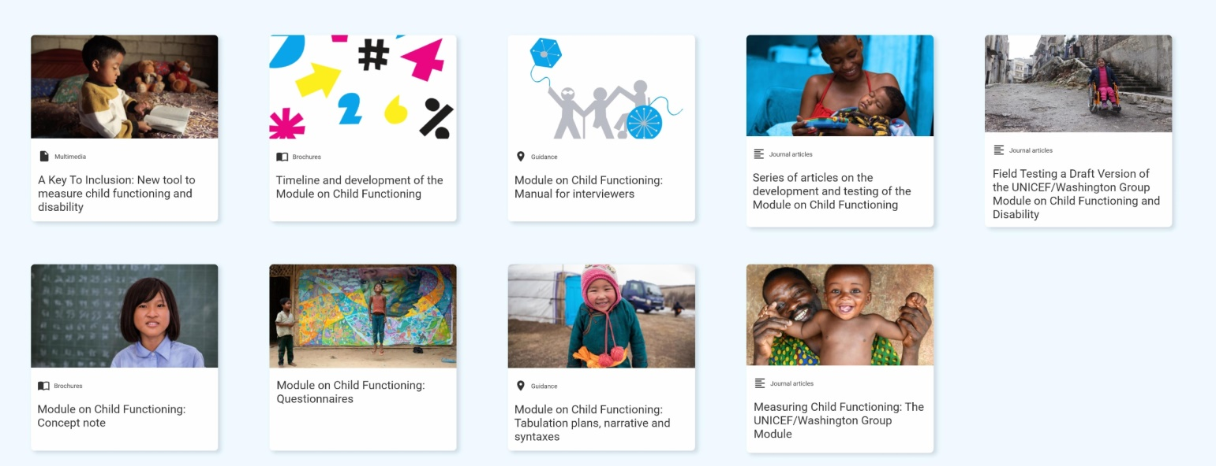
- Multimedia: A Key To Inclusion: New tool to measure child functioning and disability
- Brochure: Timeline and development of the Module on Child Functioning
- Guidance: Module on Child Functioning: Manual for interviewers
- Journal articles: Series of articles on the development and testing of the Module on Child Functioning
- Journal articles: Field Testing a Draft Version of the UNICEF/Washington Group
- Brochure: Module on Child Functioning: Concept note
- Module on Child Functioning: Questionnaires
- Guidance: Module on Child Functioning: Tabulation plans, narrative and syntaxes
- Journal articles: Measuring Child Functioning: The UNICEF/Washington Group Module
https://data.unicef.org/topic/child-disability/module-on-child-functioning/

Slide: Measuring Disability in Zambia
- A survey of Living Conditions among People with Disabilities in Zambia (2006) used the WG-SS
- 6 questions, each with 4 response categories
- Disability cut-off chosen: at least one functioning domain that is coded as a lot of difficulty or cannot do it at all
- Prevalence 8.5%

Slide: Problematic Questions
Questions used to identify persons with disabilities in the 1990 Zambia Census
1. Are you disabled in any way? - Yes/No
2. What is your disability?
Blind - Yes/No
Deaf/dumb - Yes/No
Crippled - Yes/No
Mentally retarded - Yes/No
Disability prevalence – 0.9%
A medical model approach based on identifying and measuring impairments

Slide: WG Short Set on Functioning (WG-SS)
- Do you have difficulty seeing even if wearing glasses?
- Do you have difficulty hearing even if using a hearing aid?
- Do you have difficulty walking or climbing stairs?
- Do you have difficulty remembering or concentrating?
- Do you have difficulty with self-care such as washing all over or dressing?
- Using your usual language, do you have difficulty communicating (for example understanding or being understood by others)?
Response categories
No difficulty; Some difficulty; A lot of difficulty; Cannot do at all

Slide: Have we met the UNCRPD and SDG Objectives?
- If percentages are at equal height, we have
- If percentages are not at equal height, we have not
Category | % Employed
Without disability | 85%
With disability | 30%

