mics Manual for Anthropometry

Survey Coordinators:

Translate this manual into the language(s) of field team members.

During anthropometry training ensure that this manual is provided to all field team members - measurers, interviewers, field supervisors, and field editors.

Measurers should carry this manual with them at all times in the field.

Extensive training should be provided to field staff on using anthropometric equipment. Please see the MICS training guidelines for recommendations on organising anthropometry training.

it is important that only the equipment recommended by UNICEF is used during data collection. Please see the MICS Supply Procurement Instructions.

Delete this box as it is meant only for Survey Coordinators.

Note that these Instructions are designed for paper-based surveys and will require minor customization if the survey is conducted using tablets / PDAs.

Introduction to the Manual

This Manual is intended for all MICS field staff and outlines the required steps that need to be taken during MICS data collection in order to accurately measure and weigh children. It is easy to make errors in measurements when not being careful. Measurers in particular should carry these instructions with them in the field and review them regularly to make sure they are always following the correct procedures. Supervisors should also frequently refer to this Manual in the field when observing the work of measurers.

Responsibilities of Field Team Members During the Collection of Anthropometric measurements

Measurers: Taking anthropometric measurements of children is the main responsibility of the team measurer and requires that he or she follows the procedures specified in this manual and that no steps in the procedures are omitted. Measurers will be assisted by another trained team member however it should be emphasised that the measurer will hold the overall responsibility for determining final measurements and making sure they have been properly recorded on the under-five questionnaire.

The measurer is also responsible for carrying and taking care of the equipment used for anthropometric measurements and reporting to the supervisor immediately if any of the equipment is malfunctioning.

Interviewers, field editors, and field supervisors: Two trained people are always required to measure a child’s height and length; a measurer and an assistant. The assistant may be an interviewer, field editor, or a field supervisor as long as they have undergone the MICS anthropometry training. The measurer holds the child and reads the measurements while the assistant helps hold the child and records the measurements on the questionnaire.

Under no circumstances should an untrained person such as a mother or other caregiver of the child assist in taking the length or height measurement. It is however recommended that a mother or caretaker be near to the child to comfort them and assist in putting the child at ease so that the child can be measured.

Field editors: Editors will be expected to check the recorded anthropometry measurements on each completed Questionnaire for Children Under Five as part of their routine editing work. Editors should pay special attention to the values to make sure they lie within the ranges specified in Table 1 at the end of this Manual (and in the Instructions for Supervisors and Editors). If a value falls outside the acceptable range, the editor should ask the measurer to revisit the household, re-measure the child, and check that the child’s age has been correctly recorded. Please note that measurements outside the ranges given in Table 1 are possible, but incredibly rare (no more than a few per survey).

Field supervisors: Supervisors will be responsible to coordinate the work of the measurer by making sure he/she knows where to find the households that interviewers are conducting interviews in and to know approximately how many children and at what time the measurer should visit the household. The supervisor is also expected to regularly observe the measurer and assistants performing anthropometric measurements. The supervisors will be responsible for ensuring that measurements are taken following the exact steps and procedures outlined in this Manual. In situations where measurers are routinely making errors in taking and/or reading measurement, in manipulating children and/or equipment, and in reporting the information on the questionnaire, the supervisor should consult with the fieldwork director and/or survey coordinator when necessary.

General Precautions for Measurers and Assistants

- Placement of the measuring board and electronic scale
Measurers should begin to observe possible places where the electronic scale and board can be positioned as soon as they walk into a sample household. They should be selective about where the measuring board and electronic scale is placed. During daylight hours, it is best to measure outdoors. If it is cold, rainy, or if too many people congregate and interfere with the measurements, it may be more comfortable to weigh and measure a child indoors. Make sure there is adequate light and ensure you place the equipment on a flat and even surface.

- When to weigh and measure
Weights and heights of all eligible children age under five living in the household will be measured after all the Questionnaires for Children Under Five are completed. However, if some respondents or children have to leave the household before all questionnaires in the household have been completed, or if a call-back has to be made to interview another respondent, it is best to complete the measurements of those children who are present. Do not weigh and measure at the beginning of the interview, that is, as soon as you enter a household, since this would likely be perceived as overly intrusive.

It is the supervisors’ responsibility to coordinate the work of the measurer so that the measurers visit households at the convenient time before the interviewers leave to their next household. If households within a cluster are scattered then transport and logistics issues need to be well planned. Good planning will help to ensure that measurers are not wasting time waiting in one household for the interviews to finish, while other interviewers have completed their interviews and are waiting with the respondents and children for the measurer to arrive.
- Weigh and measure one child at a time
In cases when there is more than one eligible child of the same mother/caretaker, complete all the questionnaires for the mother/caretaker, and then weigh and measure all her/his children one after the other making sure not to confuse questionnaires. If there is more than one mother/caretaker with children under 5 in the same household, care should be taken over the timing and the organization of the measurements, and good judgement be applied in such cases. If it is considered that leaving all of the measurements until after the completion of all questionnaires will cause confusion and errors, then measurements of children by the same mother/caretaker should be conducted once the questionnaires administered to that mother/caretaker have been completed, and then the measurer moves on to children of the next mother/caretaker. However, in reality, it is often the case that interviewing all mothers/caretakers first, and measuring all children at the end is more practical – use this option if it will not cause confusion. It is very important to complete both the weight and the height/length measurements for one child before continuing with the next eligible child.
- Controlling and taking care of the child
When children are weighed and measured, the measurer and assistant must take care to gently control the child. The strength and mobility of even very young children should not be underestimated. Needless to say, a gentle but firm approach is necessary. Do not apply excessive force on children’s limbs to get measurements. The measurer’s own sense of calm and self-confidence will be felt by the mother and the child.

When a child comes into contact with any measuring equipment, that is, a measuring board or electronic scale, children must be held carefully so they do not trip or fall. Children should never be left alone with a piece of equipment; physical contact with the child, except for the few seconds while taking his or her weight, should always be maintained.

Measurers and assistants should keep objects out of their hands and pens out of their mouth, hair, or breast pocket when a child is being weighed and measured so that the child will not get hurt due to carelessness. When the pen is not being used it should be placed in the equipment pack, pen case, or on the survey form. Measures and assistants should not have long fingernails and should remove rings and watches before they weigh and measure children to prevent them from getting in the way or harming the child. No member of the field team should smoke when in a household or in the process of taking measurements.
- Coping with stress
Since weighing and measuring requires touching and handling children, normal stress levels for this part of the survey work is higher than for where only verbal information is collected.

Measurers should explain the weighing and measuring procedures to the mother and, to a limited extent, the child, to help minimize possible resistance, fear, or discomfort. It should be determined if the child or mother is under so much stress that the weighing and measuring must stop. Remember, young children are often uncooperative; they tend to cry, scream, kick, and sometimes bite. If a child is under severe stress and is crying excessively, attempts to calm the child should be made for example by returning the child to the mother for a moment before proceeding with the weighing and measuring.

If a child is terrified and cries too much this can have a big impact on the other children of the household that need to measured. It is better to leave the distressed child to calm down and to come back later to try and weigh and measure the child again. In some cases it may be possible to weigh and measure a distressed child after he or she has seen other children such as his or her siblings in the household being measured.

Do not weigh or measure a child if:
- The mother refuses.
- The child is too sick or too distressed.
- The child is physically deformed, which will interfere with or give an incorrect measurement. To be sensitive to the feelings of such a child, its parents, and other children, you may want to measure the child and make note of the deformity on the questionnaire.

- Take good care of the equipment and keep it clean
The equipment needs to be cleaned on a very regular basis as it easily becomes dirty. As a courtesy it is important to clean the wooden height boards in between children as the feet and head are placed on the same spot of the wooden board depending on the age of the child.
- Strive for improvement
People can become very skilled in taking measurements if they strive for improvement and follow every step of every procedure the same way every time. The quality and speed of measurements will improve with practice. Do not take these procedures for granted, even though they may seem simple and repetitious and do not omit any of the steps.

- Hygiene
Do not handle children without clean hands. Likewise, cleaning hands after handling a child is recommended. It is advisable to carry wet napkins/wipes, an alcohol-based hand gel, or similar to clean hands before and after handling a child. There will be households in which soap and water is not available and others where measurement without cleaning hands will not be allowed.
Measuring a Child’s Weight: Summary of Procedures

The Seca 874 U Electronic Scale
During MICS data collection children should only be weighed using the Seca 874 U Scale. If for any reason the scale is not working during field work then the measurer should immediately inform the team supervisor who will contact the fieldwork director to request a new scale. It is highly recommended that teams carry a back-up scale, so that fieldwork is not interrupted due to problems with one scale.

Setting up the scale for use
- To turn on the scale, carefully turn it over so that the base is accessible. Open the battery compartment and insert the supplied batteries. To activate the power supply, push the switch located in the battery compartment in position “ON”.
- Scales should always be placed on a hard, level surface (wood, concrete, or firm earth). Soft or uneven surfaces may cause errors in weighing.
- The scale will not function correctly if it becomes too warm or too cold. It is best to use the scale in the shade, or indoors. If the scale becomes hot and does not work correctly, place it in a cooler area and wait 15 minutes before using it again. Make sure to check the surface if the scale for any reason has been left in direct sunlight, as the black surface can become extremely hot and easily burn bare feet. If it becomes too cold, place it in a warmer area.
- The scale must adjust to changes in temperature. If the scale is moved to a new site with a different temperature, wait for 15 minutes before using it again.
- It is a sturdy yet sensitive electronic piece of equipment. The scale must be tested every single day of fieldwork. This is best done using a labelled standard weight of 2.5 – 5.0 kg. This can be purchased locally, but must be tested initially to ensure that the indicated weight is accurate. Record the results of the daily test of the scale, including the date and weight.
- Using other types of standard weights is possible, but is not recommended. Some surveys have in the past used filled water bottles for testing, but as water or other liquids evaporate, this technique is flawed. Sand is a viable alternative, but only if labelled weights are not available.
- In addition, it is recommended that the tared weight function is tested.
- In reference to the scale’s minimum and maximum operating temperatures, it is advisable to test the scale before every measurement when the scale is moved and operated in extreme weather conditions.
- Actual calibration cannot be done in the field, but only by a technician. Therefore the scale should be immediately replaced if readings are off.

Switching off the scale
The scale switches off automatically;
- after 3 minutes in normal mode or
- after 2 minutes, if the mother-and-baby function is switched on.

Maintaining and storing the scale
Always handle the scale carefully:
- Do not drop or bump the scale.
- Do not weigh loads totalling more than 150 kilograms.
- Protect the scale from excess moisture or humidity.
- Do not use the scale at temperatures below 10º C or above 40º C. Test the scale if transported or used under such circumstances.

To clean the scale, wipe surfaces with a damp cloth. Never put the scale into water.

Do not store the scale in direct sunlight or other hot places.

The Seca 874 U scale is powered exclusively by batteries. 120,000 weighing operations can be performed with one set of batteries. The scale uses four type AA 1.5 V batteries that are easily replaceable.

Preparing the child for weighing
Explain to parents/caretakers that the child needs to remove outer clothing in order to obtain an accurate weight. A wet diaper, or shoes and jeans, can weigh more than 0.5 kg. Babies should be weighed naked; wrap them in a blanket to keep them warm until weighing. When using the 2 in 1 or tared weighing described below, the adult can be weighed holding a blanket, which he/she can then wrap around the naked baby during measurement. Older children should remove all but minimal clothing, such as their underclothes.

If it is too cold to undress a child or if the child resists being undressed and becomes agitated, please weigh the clothed child, but code in the questionnaire (AN3A) that the child could not be undressed to the minimum and take a note of the circumstances.

Weighing a child that is less than 2 years old (tared weighing)
The 2 in 1 function enables the body weight of infants and young children to be determined. The child is held in the arms of the mother/caretaker (or another adult if necessary).
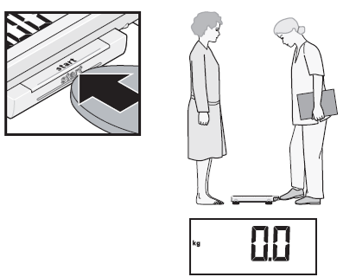
- Measurers:
- Switch on the scale with no weight applied.
Wait until 0.0 appears on the display

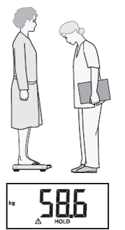

- Ask the mother/caretaker to step onto the scale.
The weight is displayed.
Note: The person being weighed on the scale
must stand very still.

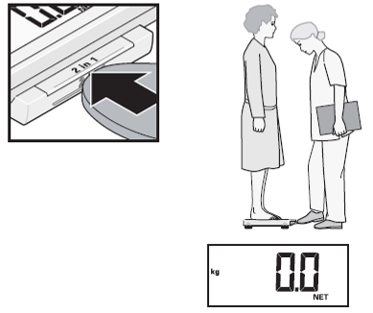
- Measurers:
- Press the 2 in 1 key.
The weight is stored.
0.0 and the word NET appear on the display.

- Ask the mother/caretaker to hold the first baby while standing on the scale and to try not to move.
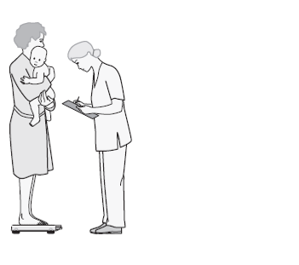
- Wait until the weight display and the message HOLD are no longer flashing.
- Read out the baby’s weight to the assistant.
- Confirm the correct weight has been recorded.
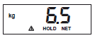
- Ask the mother to step off the scale with the baby.
- The baby’s weight remains displayed.
- The adult’s weight remains stored. A new child measurement is automatically taken as soon as any weight is placed on the scale again.
- You can therefore take measurements of other babies in the same way with the same adult. You do not need to reactivate the 2 in 1 function or switch the scale off and on again between measurements. It is important that this person’s weight does not change (e.g. by taking off a garment). If no measurements have been taken for two minutes, the 2 in 1 function and the scale automatically switch off and the process needs to begin again.

After each child’s weight has been taken, the measurer reads out the value on the display of the scale and the assistant repeats back the value. If the measurer confirms this is correct the assistant records the value on the questionnaire in AN3. The measurer should check the weight that has been recorded after the weight measurement of each child has been completed.

Weighing a child that is 2 years or older
If the child is 2 years or older and willing to stand still, weigh the child alone.
- Explain to the child that they will need to step on the scale alone and stand very still. Communicate with the child in a sensitive, non-frightening way.
- Measurer: Switch on the scale with no weight applied.
- Wait until the display shows 0.0 before asking the child to step on the scale.
- Ask the child to stand in the middle of the scale, feet slightly apart and to remain still until the weight appears on the display. Do not hold or support the child as this will interfere with the measurement.
- Once the value is stable for about 3 seconds, the display is retained. This avoids the display jumping around as a result of the child’s movements.
- If the child jumps on the scale or will not stand still, you will need to use the tared weighing procedure instead (please see above).
- Read out loud the child’s weight from the display.
- Assistant: Repeat the weight that has just been called out.
- Measurer: Confirm if this is the correct weight. If it is correct then the assistant will record the weight on the questionnaire.
- Assistant: If measurer confirms, record weight in AN3.
- Measurer: Check the weight recorded in AN3 to confirm that it matches the weight that was on the display.
- The child can then leave the scale.

NOTE:
Even though the displays of the Seca 874 U scales show two decimals, the last decimal is set to always show 0. To be consistent with the corresponding question (AN3) in the Questionnaire for Children Under Five, the scales provided by UNICEF have a sticker on the display facing the measurer, allowing the measurer to see only the first decimal of the measurement. Two decimals are shown on the display facing the child.
Measuring a Child’s Height: Summary of Procedures for when a child is over 2 years of age (see Illustration 1)

- Measurer or assistant: Place the measuring board on a hard flat surface against a wall, table, tree, staircase, etc. Make sure the board is stable. If the only level surface available to place the board does not have a steady structure against where to lean it, and there are no sturdy pieces of furniture that can be moved behind it, have an adult stand behind the board and provide the support for it not to tip over.
- Measurer or assistant: Ask the mother/caretaker to remove the child’s shoes and socks. Also ask, if necessary, the mother to unbraid any hair that would interfere with the height measurement and add to the child’s height. Then ask her/him to walk the child to the board and to kneel in front of the child.
- Assistant: Place the questionnaire and pen on the ground (Arrow 1). Kneel with both knees on the child’s right side (Arrow 2).
- Measurer: Kneel on your right knee only, for maximum mobility, on the child’s left side (Arrow 3).
- Assistant: Place the child’s feet flat and together in the centre of and against the back and base of the board. Place your right hand just above the child’s ankles on the shins (Arrow 4), your left hand on the child’s knees (Arrow 5), and push against the board. Make sure the child’s legs are straight and the heels and calves are against the board (Arrows 6 and 7). Tell the measurer when you have completed positioning the feet and legs.
- Measurer: Tell the child to look straight ahead at the mother if she is in front of the child. Make sure the child’s line of sight is level with the ground (Arrow 8). Place your open left hand on the child’s chin. Gradually close your hand (Arrow 9). Do not pinch the jaw. Do not cover the child’s mouth or ears. Make sure the shoulders are level (Arrow 10), the hands are at the child’s side (Arrow 11), and the head, shoulder blades, and buttocks are against the board (Arrows 12, 13 and 14). With your right hand, lower the headpiece on top of the child’s head. Make sure you push through the child’s hair (Arrow 15).
- Measurer and assistant: Check the child’s position (Arrows 6-14). Repeat any steps as necessary.
- Measurer: When the child’s position is correct, read and call out the measurement to the nearest 0.1 centimetre. Remove the headpiece from the child’s head, your left hand from the child’s chin and support the child during the recording.
- Assistant: Immediately record the measurement in AN4 and show it to the measurer. Alternatively, the assistant could call out the measurement and have the measurer confirm by repeating back.
- Assistant: Record in AN4A whether the child was measured lying down or standing up.
- Measurer: Check the recorded measurement on the questionnaire for accuracy and legibility. Instruct the assistant to cancel and correct any errors.

NOTE:
If the interviewer is not confident in the precision of the child’s age (over age 2), please take measurement as described above. If the child’s height is measured to less than 85 cm, you must instead measure the child’s length.

Illustration 1. Measuring a child’s height.
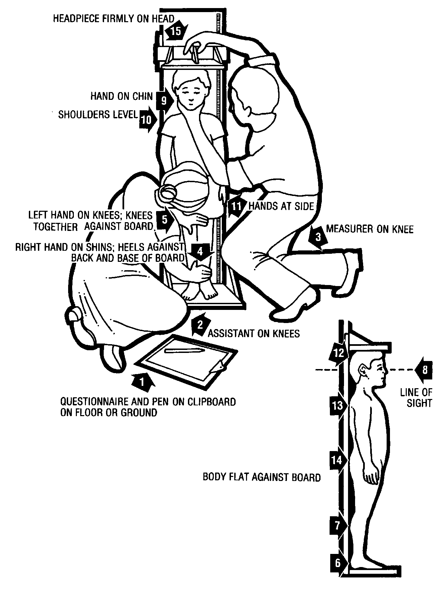
Measuring a Child’s Length: Summary of Procedures for when a child is under 2 years of age (see Illustration 2)

- Measurer or assistant: Place the measuring board on a hard flat surface, such as the ground, floor or a steady table.
- Assistant: Place the questionnaire and pen on the ground, floor or table (Arrow 1). Kneel with both knees behind the base of the board, if it is on the ground or floor (Arrow 2).
- Measurer: Kneel on the child’s right side so that you can hold the footpiece with your right hand (Arrow 3).
- Measurer and assistant: With the mother’s/caretaker’s help, lay the child on the board by doing the following:
Assistant: Support the back of the child’s head with your hands and gradually lower the child onto the board.
Measurer: Support the child at the trunk of the body.
- Measurer or assistant: Ask the mother/caretaker to kneel on the opposite side of the board facing the measurer to help keep the child calm.
- Assistant: Cup your hands over the child’s ears (Arrow 4). With your arms comfortably straight (Arrow 5), place the child’s head against the base of the board so that the child is looking straight up. The child’s line of sight should be perpendicular to the ground (Arrow 6). Your head should be straight over the child’s head. Look directly into the child’s eyes.
- Measurer: Make sure the child is lying flat and in the centre of the board (Arrow 7). Place your left hand on the child’s shins (above the ankles) or on the knees (Arrow 8). Press them firmly against the board. With your right hand, place the footpiece firmly against the child’s heels (Arrow 9).
- Measurer and assistant: Check the child’s position (Arrows 4-9). Repeat any steps as necessary.
- Measurer: When the child’s position is correct, read and call out the measurement to the nearest 0.1 centimetre. Remove the footpiece, release your left hand from the child’s shins or knees and support the child during the recording.
- Assistant: Immediately release the child’s head, record the measurement in AN4 and show it to the measurer. Alternatively, the assistant could call out the measurement and have the measurer confirm by repeating back.
- Assistant: Record in AN4A whether the child was measured lying down or standing up.
- Measurer: Check the recorded measurement on the questionnaire for accuracy and legibility. Instruct the assistant to cancel and correct any errors.

NOTE:
If the interviewer is not confident in the precision of the child’s age (under age 2), please take measurement as described above. If the child’s length is measured to 85 cm or more, you must instead measure the child’s height.

Illustration 2. Measuring a child’s length.
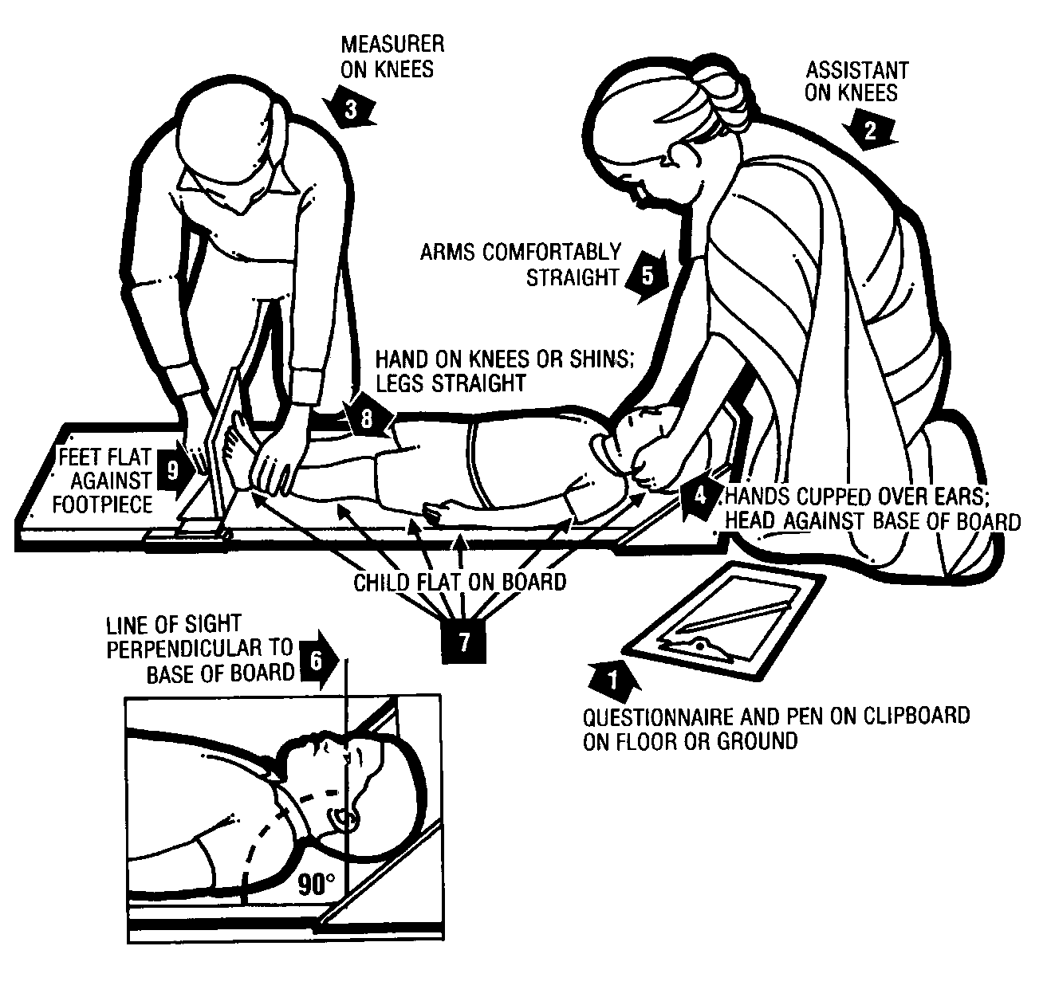

Table 1
Expected Length and Weight of Children by Sex and Age in Months

In editing the recorded length and weight of children to ensure that no data entry errors are made, the following values are used as the minimum and maximum expected values. The ranges are dependent on the sex and age of the child and are given in centimetres for the length (height) of the child and kilograms for the weight of the child.

Age in  Months | Length/height (cm) |  |  |  | Weight (kg)
 | Males |  | Females |  | Males |  | Females
 | Min | Max | Min | Max | Min | Max | Min | Max
0–2 | 36.0 | 74.0 | 36.0 | 72.0 | 0.5 | 10.0 | 0.5 | 9.0
3–5 | 45.0 | 83.0 | 44.0 | 80.0 | 1.0 | 13.0 | 1.0 | 12.0
6–8 | 51.0 | 87.0 | 50.0 | 86.0 | 2.0 | 15.0 | 2.0 | 14.0
9–11 | 56.0 | 91.0 | 54.0 | 90.0 | 3.0 | 16.5 | 2.5 | 15.5
12–14 | 59.0 | 96.0 | 57.0 | 95.0 | 4.0 | 17.5 | 3.0 | 16.5
15–17 | 62.0 | 100.0 | 60.0 | 99.0 | 4.0 | 18.5 | 3.5 | 17.5
18–20 | 64.0 | 104.0 | 62.0 | 102.0 | 4.0 | 19.5 | 3.5 | 18.5
21–23 | 65.0 | 107.0 | 64.0 | 106.0 | 4.5 | 20.5 | 4.0 | 19.5
24–26 | 67.0 | 108.0 | 66.0 | 107.0 | 4.5 | 23.0 | 4.5 | 21.5
27–29 | 68.0 | 112.0 | 68.0 | 111.0 | 5.0 | 24.0 | 5.0 | 23.0
30–32 | 70.0 | 115.0 | 69.0 | 114.0 | 5.0 | 24.5 | 5.0 | 24.5
33–35 | 71.0 | 118.0 | 71.0 | 117.0 | 5.0 | 25.5 | 5.0 | 25.5
36–38 | 73.0 | 121.0 | 72.0 | 120.0 | 5.0 | 26.0 | 5.0 | 27.0
39–41 | 74.0 | 124.0 | 74.0 | 122.0 | 5.0 | 27.0 | 5.0 | 28.0
42–44 | 75.0 | 127.0 | 75.0 | 124.0 | 5.0 | 28.0 | 5.5 | 29.0
45–47 | 77.0 | 129.9 | 77.0 | 126.0 | 5.0 | 29.0 | 5.5 | 30.0
48–50 | 78.0 | 132.0 | 78.0 | 129.0 | 5.0 | 30.0 | 5.5 | 31.0
51–53 | 79.0 | 134.0 | 79.0 | 131.0 | 5.0 | 31.0 | 5.5 | 32.0
54–56 | 80.0 | 136.0 | 81.0 | 133.0 | 5.5 | 32.0 | 6.0 | 33.0
57–59 | 82.0 | 139.0 | 81.0 | 136.0 | 5.5 | 33.0 | 6.0 | 34.5

This manual has been developed by UNICEF to be used for Multiple Indicator Cluster Surveys (MICS). The manual draws heavily on resources developed by the World Health Organization (WHO), Action Contre la Faim Canada, and the Food and Nutrition Technical Assistance Project (FANTA). The authors would like to thank WHO, Action Contre la Faim, and FANTA for the kind permission to use their materials. The illustrations and summary procedures for measuring length or height are adapted from How to Weigh and Measure Children: Assessing the Nutritional Status of Young Children in Household Surveys, Annex I, Summary Procedures prepared by the United Nations Department of Technical Co-operation, Development and Statistical Office (New York: 1986).

